Possible titles…

Tracking fast and slow changes in synaptic weights from simultaneously observed pre- and postsynaptic spiking activity

# Abstract

# Introduction

Basic statement of the problem.

Synapses change on multiple timescales

We may be able to track these changes from spikes

Detecting putative synaptic connections from spikes is the first step, and many previous approaches have addressed this problem (e.g. <https://www.nature.com/articles/s41467-019-12225-2>). Basic review of correlogram-based methods, model-based methods. 1

In addition to detecting connections or estimating an average weight, some recent work with model-based methods has aimed to track changes in putative synaptic weights. Short-term plasticity 2,3, spike-timing dependent plasticity 4. (<http://papers.nips.cc/paper/5274-a-framework-for-studying-synaptic-plasticity-with-neural-spike-train-data>)

Why do we need to model \*both\* short- and long-term changes? Short-term plasticity has effects on slower timescales (due to changes in equilibrium) (e.g. 5). When both short- and long-term plasticity are present ignoring short-term plasticity can lead to biased estimates of long-term plasticity and ignoring long-term plasticity can lead to biased estimates of short-term plasticity [would be good to have an illustration of this].

Basic summary of 1) the modeling approach, 2) statistically-focused simulations, 3) the neurobiologically-focused simulations.

# Results

Here we extended the common Generalized Linear Model to describe both short- and long-term changes in the coupling between a pre- and post-synaptic neuron. The short-term effects were estimated by linear model on basis functions, and the long-term effects are estimated by Point Process Adaptive Smoothing. These two estimations were conducted in an alternative way.

We first showed several simulation examples for this method, with consideration of different STP type, different LTP pattern and different baseline pattern. However, the optima are not guaranteed to be the global optima, and the performance of this method is highly affected by the process noise covariance (i.e. $Q$ in the adaptive smoothing). Therefore, we further 1) checked the convergence by random start points and switching order between short- and long-term effect estimations and 2) provide a way to estimate the $Q$.

Then, we further evaluated the estimation performance under different neuron properties, such as pre- and post-synaptic firing rates, types of STP and type of synapses.

**Simulation Examples**

To show the model can track fast and slow changes in synaptic weights, several simulation examples were shown as follows. The simulations were divided into two groups based on 1) STP types and 2) change mode of LTP and baseline. In these examples, the recording time length is T = 20 min and the pre-synaptic firing rate is 5Hz. The Q were all set to be 1e-5 temporarily, which may be further automatically tuned. After fitting the model, 1) trace plots of pre- and postsynaptic rates, 2) overall correlogram and 3) modification functions were shown. The correlograms were further split by quartiles of ISI or recording length T to show STP and LTP, respectively. The black lines and bars represent observed/ true values, while the red ones represent the model generated/ fitted values. the dashed (red) lines for modification functions represent one standard error range around estimated values.

**Examples for different LTP types**

Simulations on different LTP types, i.e. 1) facilitation, 2) depression and 3) no plasticity, were shown as follows. In these cases, the baseline and long-term effect (LTP) were set as constant. Correlogram was split by quartiles of ISI to show STP.

1) Facilitation

|  |  |  |
| --- | --- | --- |
| Pre- and post-synaptic firing rate | Overall cross-correlogram | Modification function |
|  | 3_overallCorr | 1_modificationFuntion |

Cross-correlogram by quartiles of ISI

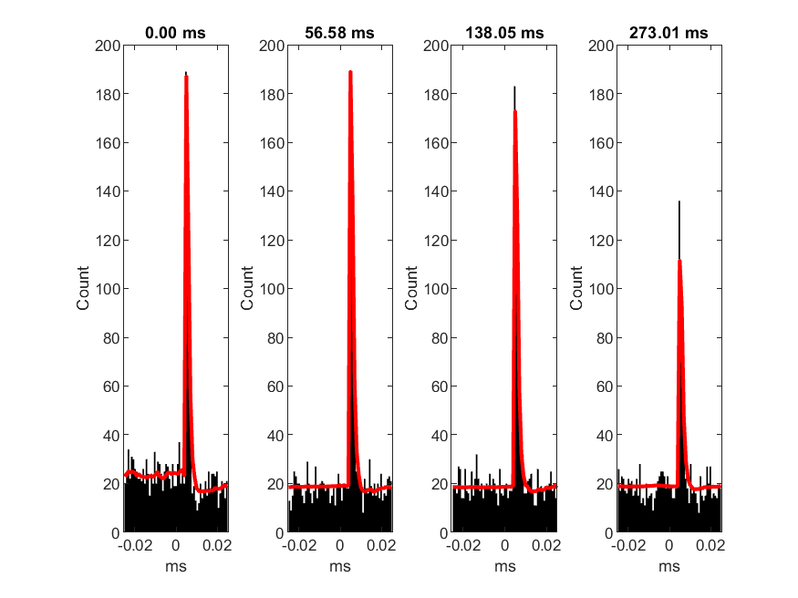

Cross-correlogram by quartiles of T

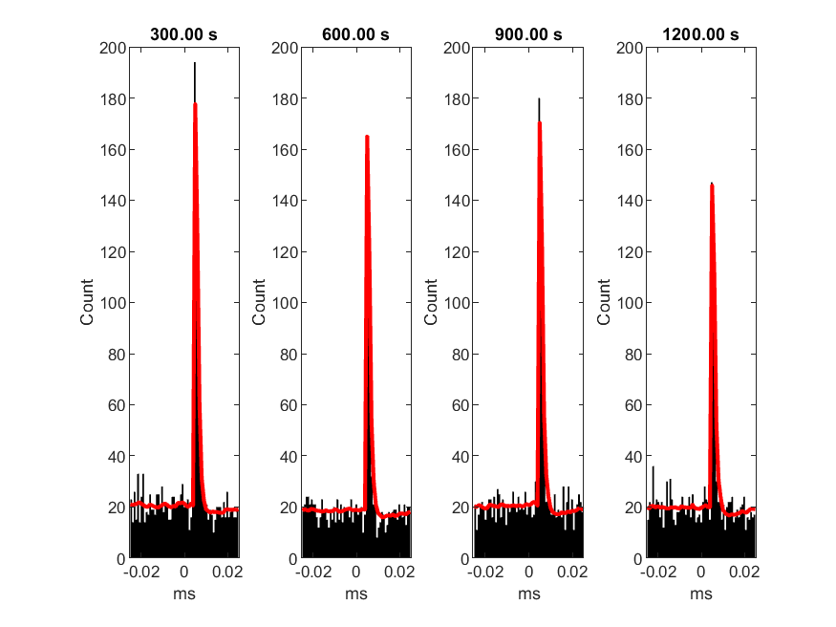

2) Depression

|  |  |  |
| --- | --- | --- |
| Pre- and post-synaptic firing rate | Overall cross-correlogram | Modification function |
|  |  |  |

Cross-correlogram by quartiles of ISI

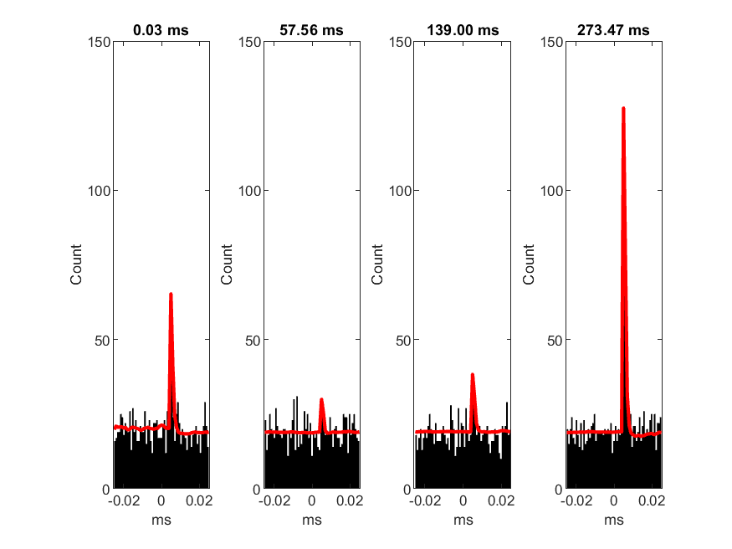

Cross-correlogram by quartiles of T

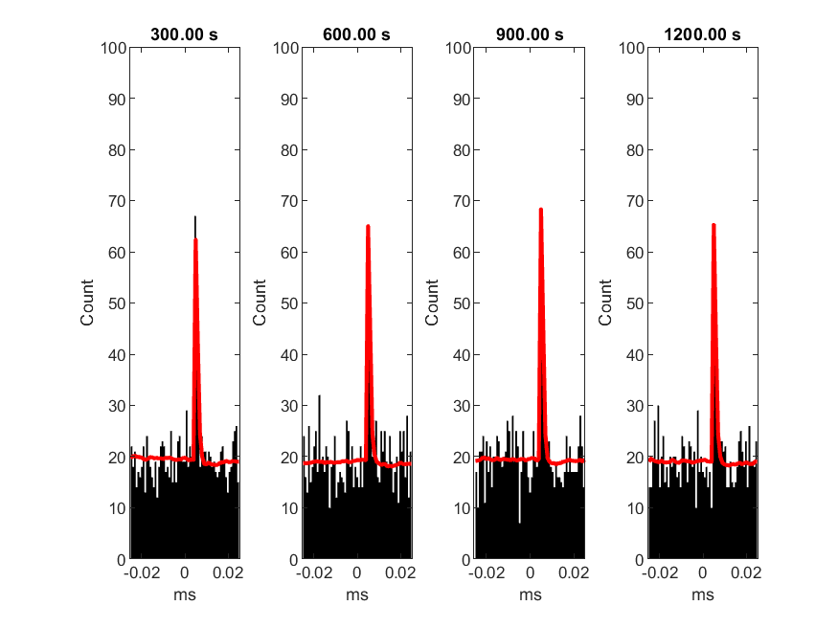

3) No Plasticity

|  |  |  |
| --- | --- | --- |
| Pre- and post-synaptic firing rate | Overall cross-correlogram | Modification function |
|  |  |  |

Cross-correlogram by quartiles of ISI

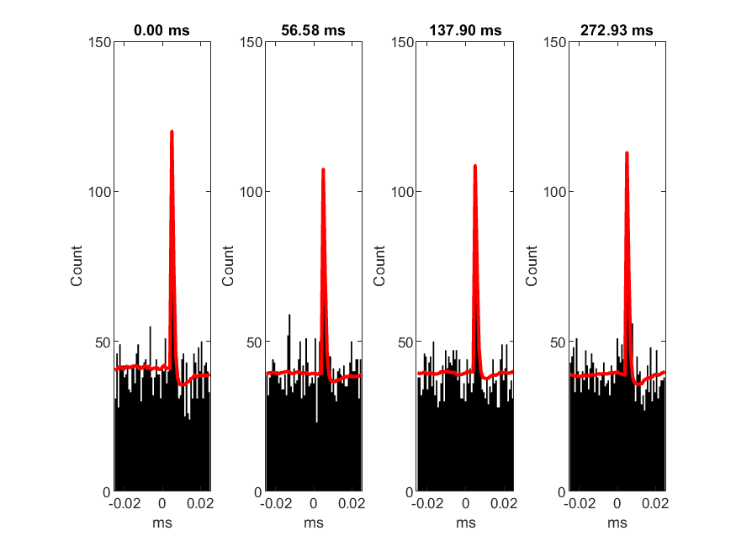

Cross-correlogram by quartiles of T

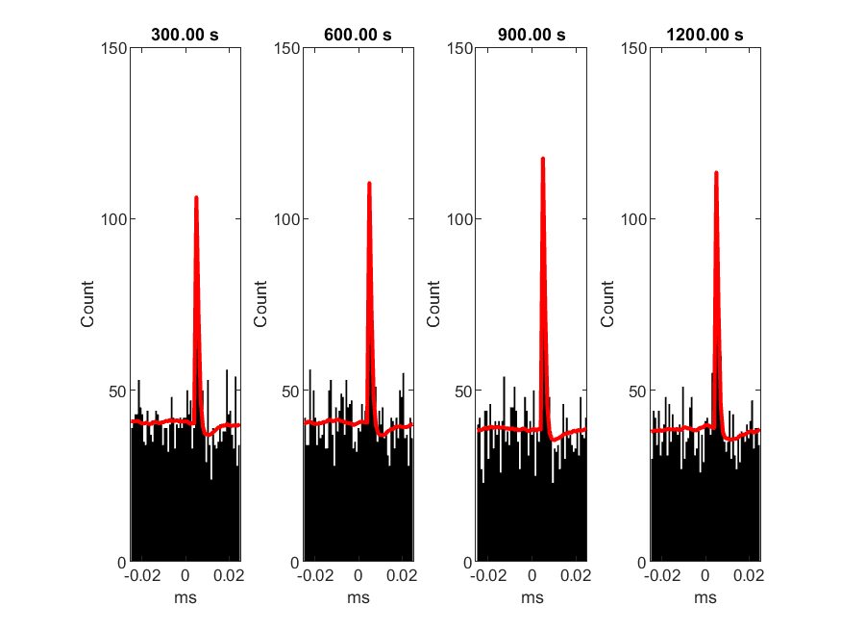

**Examples for different baseline and LTP change**

Here we fix the short-term plasticity to be depression and show examples with combinations of three (linear, jump and sinusoidal) change patterns. Specifically, there are two examples: 1) linear baseline + jump LTP; 2) sinusoidal baseline and LTP.

1) case 1: linear baseline + jump LTP + depression STP

|  |  |  |
| --- | --- | --- |
| Pre- and post-synaptic firing rate | Overall cross-correlogram | Modification function |
|  |  |  |

Cross-correlogram by quartiles of T

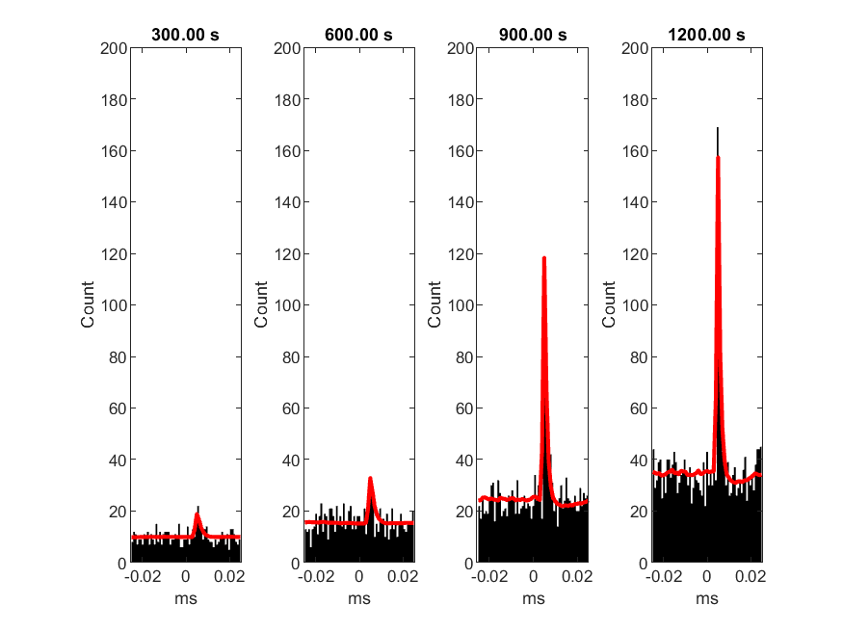

2) case 2: sinusoidal baseline and LTP + depression STP

|  |  |  |
| --- | --- | --- |
| Pre- and post-synaptic firing rate | Overall cross-correlogram | Modification function |
|  |  |  |

Cross-correlogram by quartiles of T

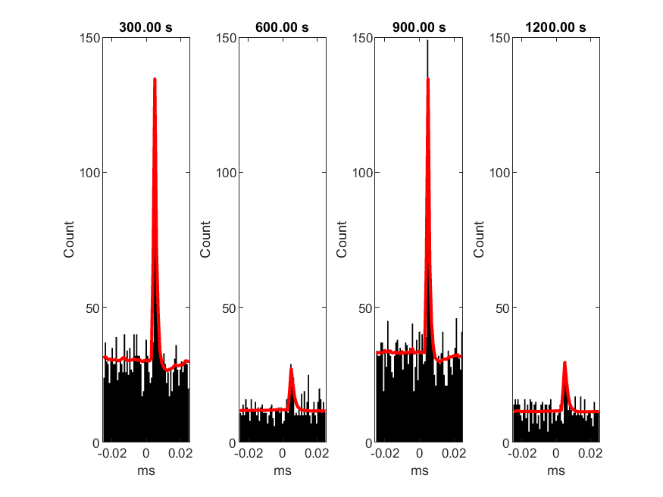

These examples show that the model can handle most cases. In the following, we investigate the model properties by different angles. The recording length are all 10min, if without specifying.

**Statistical considerations**

**Convergence Check**

The convergence of the algorithm was checked by random start and switching order between long-term effect estimations and short-term effect estimations. The length of T is 10 min, the firing rate for pre-synaptic spike is 5Hz, and Q is set as 1e-5 for both baseline and LTP. The optimization was conducted in two orders: 1) estimating long-term effect at first and then estimating short-term effect; 2) estimating short-term effect at first and then estimating long-term effect. 6 random starts were implemented for each optimization order.

Here we show the deviance and parameters track for order 1. For order 2, the influence of random start is even far less. The deviance track:



After few iterations, the deviances for different random start points converge to the same value.

The track for baseline (show start, iteration 2 and iteration 4):

|  |  |  |
| --- | --- | --- |
| start | Iteration 2 | Iteration 4 |
|  |  |  |

The track for LTP (show start, iteration 2 and iteration 4):

|  |  |  |
| --- | --- | --- |
| start | Iteration 2 | Iteration 4 |
|  |  |  |

The track for modification function (show start, iteration 2 and iteration 4):

|  |  |  |
| --- | --- | --- |
| start | Iteration 2 | Iteration 4 |
|  |  |  |

Although all three of them will converge finally regardless of initial values, the convergence of LTP is slower.

Next, we investigate whether these two orders converge to the same results. The rede lines represent order 1, the blue lines represent order 2 and the black line represent true values.

|  |  |  |
| --- | --- | --- |
| baseline | LTP | STP |
|  |  |  |

There are slight discrepancies of results between two orders, especially for estimation of LTP. For this case, order 1 (estimating long-term effect at first) gives a larger estimation of LTP. However, this pattern is different case by case. When doing simulation on depression case, order 2 gives a smaller estimation of LTP. After elongation of recording time, the discrepancies become negligible.

Therefore, in the following analysis, we will not implement random starts and order switch. However, we need to be cautious that the results will be slightly different by different estimation orders, especially when recording time is not long enough.

**Process Noise Covariance Q**

The process Noise Covariance Q will influence the performance of estimations a lot. Improper Q will even make the algorithm diverge. Although it’s possible to estimate Q by EM algorithm (reference 1), the convergence is slow even with an accelerator (reference 2). Here we give a fast way to select Q based on prediction likelihood of the first iteration (See details in method). Basically, we assume the Gaussian white noise variances for baseline and LTP are independent (i.e. Q is diagonal), therefore we can estimate variances independently. In this part, we show an example for estimating excitatory synapses with (medium) depression STP. The pre-synaptic firing rate is 5Hz, the LTP is set to have mean overall plasticity (LTP\*STP) to be 1.5 (i.e. mean LTP is 2.71). The baseline is set to make mean post-synaptic firing rate to be 20 Hz (i.e. mean baseline strength is 3). The true underlying Q are 1e-5 for both baseline and LTP.

We first set Q for LTP be zero and search for the optimized Q for baseline. Then fix the Q for baseline and do the same thing for LTP. The prediction likelihoods based on 1 iteration are plot against Q on log-log scale.



Based on the flatten prediction likelihood, the optimized Q is 1e-5 and 2e-6 for baseline and LTP.

The following plots show the fitting results for the optimized Q, and results when we set Q to be too large (1e-3 for both) and too small (1e-8 for both).

Q is too large (1e-3 for both baseline and LTP):

|  |  |
| --- | --- |
|  |  |

Q is too small (1e-8 for both baseline and LTP):

|  |  |
| --- | --- |
|  |  |

Optimized Q (1e-5 for baseline and 2e-6 for LTP):

|  |  |
| --- | --- |
|  |  |

**Influence of Neuron and Synapses Properties**

The neuron and synapses properties will also influence the estimation a lot. Here, we investigate: 1) firing rate of pre- and post-synaptic neurons; 2) type of STP; and 3) type of synapses (excitatory vs. inhibitory).

1) firing rate of pre- and post- synaptic neurons

Here, we fixed STP to be depression and set LTP to make mean overall plasticity to be 1.5. The baseline was also constant, but the value of it was set the achieve the interested post-synaptic firing rate. The Q were set (without tuning) as 1e-5 for both baseline and LTP. Four firing rate combinations were considered: 1) low-low: f(pre) = 5 Hz, f(post) = 15 Hz; 2) low-high: f(pre) = 5 Hz, f(post) = 30 Hz; 3) high-low f(pre) = 10 Hz, f(post) = 15 Hz; 4) high-high: f(pre) = 10 Hz, f(post) = 30 Hz. The results are shown as follows (pre- and post-synaptic firing rate, parameters estimation and modification function estimation):

Low-low: Pre = 5 Hz; post = 15 Hz

|  |  |  |
| --- | --- | --- |
|  |  |  |

Low-high: Pre = 5 Hz; post = 30 Hz

|  |  |  |
| --- | --- | --- |
|  |  |  |

High-low: Pre = 10 Hz; post = 15 Hz

|  |  |  |
| --- | --- | --- |
|  |  |  |

High-high: Pre = 10 Hz; post = 30 Hz

|  |  |  |
| --- | --- | --- |
|  |  |  |

The plots show that when increasing pre- and post- firing rate, the estimations will be more accurate (more information, less variance). When increasing the pre-synaptic firing rate, it will mainly increase the estimation accuracy of STP. When increasing the post-synaptic firing rate, it will mainly increase the estimation accuracy of LTP.

For the pre-synaptic firing rate, we further investigate its influence on estimation variance. Here we simulate a data with no pre-synaptic spikes in the middle of recording time and for the others the mean pre-synaptic firing rate is 5Hz. Here we consider depression, facilitation and no plasticity cases. The LTP for depression and facilitation are set to make mean overall plasticity be 1.5, and baseline is set to make post-synaptic firing rate be 20Hz. For example, the pre- and post-synaptic firing rate for depression is:



The estimation results:

|  |  |  |
| --- | --- | --- |
| facilitation | depression | No plasticity |
|  |  |  |

The estimation of baseline and STP are not influenced a lot when there’s no pre-synaptic spikes. However, when there’s no pre-synaptic spikes the estimation variance for LTP is large. The stronger the facilitation effect, the larger the variance (i.e. variance: depression < no plasticity < facilitation in these cases)

When setting both baseline and STP to be both be true simulated values, the estimation of LTP for these 3 cases:

|  |  |  |
| --- | --- | --- |
| Facilitation | Depression | No plasticity |
|  |  |  |

The plots also show the pattern: without pre-synaptic spikes, the estimation of LTP will have large variance. The stronger the facilitation effect, the larger the variance.

2) type of STP

Here we investigate the influence of STP type on estimation. The pre-synaptic firing rate is 5Hz. The LTPs are set to make mean overall plasticity to be 1.5. The baseline is set to make post-synaptic firing rate to be 20Hz.

|  |  |
| --- | --- |
| Facilitation | Depression |
|  |  |
|  |  |

Under the same recording length, the estimations for depression case is more accurate, especially for STP.

3) type of synapses

Here we investigated the influence of excitatory and inhibitory synapses on the evaluation performance. The STP was set as facilitation. The mean firing rate for pre- and post-synaptic neurons were set as 5 Hz and 10 Hz. The LTPs were set as 1.5 and -1.5 for excitatory and inhibitory cases. The baselines were set as constants which match the interested mean post-synaptic firing rate. The recording time is simulated as 1h. The results were shown as follows:

|  |  |
| --- | --- |
| Excitatory | Inhibitory |
|  |  |
|  |  |

The excitatory is more accurate?

**Neurobiological considerations…**

1. Consider realistic long-term changes LTP vs LTD vs STDP
   1. Relationship between STP and long-term effects

(<https://www.sciencedirect.com/science/article/pii/S0896627317308619>, <https://royalsocietypublishing.org/doi/full/10.1098/rstb.2016.0153>, <https://elifesciences.org/articles/09457>)

# Discussion

Potential for omitted variable bias. (<https://www.mitpressjournals.org/doi/abs/10.1162/neco_a_01138>)

Reminder that these methods apply to putative synapses. Detection may still be difficult. Contrast to work with intracellular recordings (<https://www.frontiersin.org/articles/10.3389/fnsyn.2019.00021/full>)

In future work, it may be possible to account for additional structure in long-term synaptic changes 6.

This work builds on model-based descriptions… Here are some papers on GLMs with coupling terms… 7–12.

Long-term plasticity can occur from a wide variety of mechanisms… STDP, LTP/LTD, heterosynaptic, changes in intrinsic excitability. (<https://journals.sagepub.com/doi/abs/10.1177/1073858414529829>)

# Methods

Inference of synaptic transmission is usually modeled based on Generalized Linear Model (GLM). Here we introduce an extension of a common GLM that9,13 aims to describe both short- and long-term changes in the coupling between a pre- and postsynaptic neuron.

**Model**

We model the postsynaptic spiking in discrete time as a doubly stochastic Poisson process with time-varying parameters. Let time $t$ be partitioned ${\left\{t_{k}\right\}}_{k=1}^{N}$, such that $0=t_{1}≤…≤t_{N}=T$ with time step as $∆=t_{k}-t_{k-1}$. Denote the total number of pre-synaptic spikes in $t∈(0,t_{k}]$ as $N_{k}^{pre}$, therefore $y_{k}^{pre}=N_{k}^{pre}-N_{k-1}^{pre}$ represents spikes in $t∈(t_{k-1},t_{k}]$. The post-synaptic notations $N_{k}^{post}$ and $y_{k}^{post}$ are defined similarly. Make $∆t_{k}$ small enough such that both $y_{k}^{pre}$ and $y_{k}^{post}$ can only take 0 or 1, and hence we can view $y_{k}^{pre}$ and $y_{k}^{post}$ as spike indicators at time $t_{k}$. Further, we define the pre-synaptic firing indexes $k_{i}$ as $\{k_{i}|y_{k_{i}}^{pre}=1,t_{k_{i}}≤t_{k_{i+1}}, i=1, 2,…\}$ and inter-spike intervals as $∆t_{k_{i}}=∆t_{k_{i}}-∆t_{k_{i-1}}$.

The post-synaptic neuron’s firing is generated by the following Poisson linear model:

|  |  |  |
| --- | --- | --- |
|  |  | (x.1) |
|  | $$y_{k}^{post}∼Poisson(λ_{k}∆t_{k})$$ | (x.2) |

where $λ_{k}$ is the conditional intensity function at $t_{k}$, which depends on a time-varying excitability $β_{0,k}$, a time-varying synaptic weight $w_{k}$ and the influence of the presynaptic neuron $x_{k}$. The synaptic weight $w_{k}$ is the multiplicative effect of long-term effect ($w_{L,k}$) and short-term effect ($w_{S,k}$).

**Estimation of Presynaptic Neuron Contribution**

The presynaptic neuron contribution, i.e. shape of the contribution, is described by alpha-function $α\left(t,t^{α},τ^{α}\right)=\frac{t-t^{α}}{τ^{α}}exp⁡(1-\frac{t-t^{α}}{τ^{α}})I(t>t^{α})$, with a latency $t^{α}$ and a time constant $τ^{α}$. Therefore, $x_{k}=\sum_{i=1}^{\{i|t_{k_{i}}≤t_{k}\}}{α(t_{k}-t_{k_{i}},t^{α},τ^{α})}$. The alpha function is estimated by modeling cross-correlogram, with consideration of both slow effects due to background fluctuations, and fast effect by synaptic connection. Briefly, the model is described as:

$λ_{cross}=\exp\left(α_{0}+X_{c}α_{c}+ w_{cross} α(t, t^{α},τ^{α}) \right)$ (x.3)

where $λ_{cross}$ is count rate for cross-correlogram. The slow effect is described as $α_{0}+X_{c}α_{c}$, with baseline $α_{0}$ and a linear combination of basis functions $X_{c}α_{c}$. The fast effect is described as $w_{cross} α(t, t^{α},τ^{α})$, where $w_{cross}$ is the connection strength from pre-synaptic neuron to post-synaptic neuron. The fast effect is estimated by a two-stage optimization on penalized Poisson log-likelihood (see details in Naixin Ren et al., 2020), and estimation for alpha function is achieved after the optimization.

**Estimation of postsynaptic excitability and synaptic weight**

The baseline firing rate and synaptic weights ($β_{0,k}$, $w_{L,k}$ and $w_{S,k}$) are divided into two groups: two long-term effects ( $β_{0,k}$ and $w_{L,k}$) , and one short-term effect ($w_{S,k}$), and estimations are conducted in two groups correspondingly.

The changes of long-term effects are relatively slow, and the effects are estimated by Point Process Adaptive Smoothing. To track the fast change for short-term effect, the linear model on basis functions is used. These two groups of estimations are conducted in an alternative way, i.e. fix one group of parameters when updating the other and alternative between two optimizations until convergence achieved.

**Estimation of Long-Term Effects: Adaptive Smoothing**

Denote the joint parameter for long-term effects as $θ_{k}=(β_{0,k}, w_{L,k})'$ and short-term contribution as $x_{S,k}=w_{S,k}⋅x_{k}$. Further, define $x_{S,k}$ as $x_{S,k}=(1, x_{S,k})'$. Therefore, the conditional intensity function can be re-written as: $λ_{k}=exp⁡(x_{S,k}^{'}θ_{k})$. The mean and covariance for $θ_{k}$ are estimated by adaptive smoothing algorithm, which can be divided into two stages: 1) forward algorithm: adaptive filtering, and 2) backward algorithm: Rauch-Tung-Striebel (RTS) smoothing.

Linear Evolution Process Equation:

$θ_{k}=F_{k-1}θ_{k-1}+η_{k}$ (x.4)

where $F_{k}$ is a system evolution matrix and $η_{k}∼N(0,Q_{k})$ represents Gaussian process noise with mean zero and covariance $Q_{k}$.

Stage One: Forward Algorithm (Adaptive Filtering)

Let $θ_{k|k-1}$ and $W_{k|k-1}$ be the model predicted mean and covariance, i.e. prior estimations, of parameter at $t_{k}$. Let $θ_{k|k}$ and $W_{k|k}$ be the adaptive filtering estimated mean and covariance after observations, i.e. posterior estimations, at $t_{k}$. Since $λ_{k}=exp⁡(x_{S,k}θ_{k})$, $\frac{∂logλ_{k}}{∂θ_{k}}=x_{S,k}^{'}$ and $\frac{∂^{2}logλ_{k}}{∂θ_{k}∂θ_{k}^{'}}=0$. Therefore, the adaptive filtering can be represented as follows:

|  |  |  |
| --- | --- | --- |
|  |  | (x.5) |
|  |  | (x.6) |
|  |  | (x.7) |
|  |  | (x.8) |
|  |  | (x.9) |

Equations (x.5) – (x.7) are prediction equations, while equations (x.8) and (x.9) are posterior corrections. The Adaptive Filtering algorithm is similar to the standard extended Kalman filter. To make this comparison more obvious, define “measurement Jocobian matrix” as $H_{k}=\frac{∂λ_{k}{\left.​\right|}_{θ_{k|k-1}}∆t_{k}}{∂θ_{k}}{\left.​\right|}_{θ_{k|k-1}}=λ_{k}{\left.​\right|}_{θ_{k|k-1}}∆t_{k}x_{S,k}^{'}$ and “Kalman gain” as $K_{k}=W_{k|k}x_{S,k}$.

Stage Two: Backward Algorithm (RTS Smoothing)

Let $θ_{k|N}$ and $W_{k|N}$ be RTS smoothing estimates for mean and covariance at $t_{k}$. The algorithm can be represented as follows:

|  |  |  |
| --- | --- | --- |
|  |  | (x.10) |
|  |  | (x.11) |
|  |  | (x.12) |

To make the algorithm numerically stable, the estimation of mean can be equivalently written as:

$θ_{k|N}=F_{k}^{-1}\left(I-Q_{k+1}W_{k+1|k}^{-1}\right)θ_{k+1|N}+F_{k}^{-1}\left(Q_{k+1}W_{k+1|k}^{-1}\right)θ_{k+1|k}$ (x.13)

In this analysis, $Q_{k}$ is set as time-constant $Q$. And to avoid bias from prior assumptions, $F_{k}$ is set as identity matrix $I$.

**Estimation of Short-Term Effect: Linear Model on Basis Functions**

The short-term synaptic weight (plasticity) is estimated by a linear model with exponential decay

|  |  |  |
| --- | --- | --- |
|  |  | (x.14) |
|  | $q_{k_{i}}=b_{Sm}^{'}\left(∆t_{k_{i}}\right)⋅α_{Sm}$ | (x.15) |

where $q_{k_{i}}$ represents the amplitude of the exponentially decaying short-term effect at $t_{k_{i}}$, and the decaying rate is time-constant $τ_{S}$. The smooth function $q_{k_{i}}$ is represented by linear combinations of raised-cosine bases, $b_{Sm}^{'}(∆t_{k_{i}})$, with log-spaced sampling knots in $∆t_{k_{i}}$. $α_{Sm}$ are coefficients for each basis function.

To simplify notations further, define $x_{Sm,k}^{'}=\sum_{i=1}^{\{i|t_{k_{i}}≤t_{k}\}}{b_{Sm}^{'}\left(∆t_{k_{i}}\right)}\exp\left(-\frac{t_{k_{i}}-t_{k}}{τ_{S}}\right))$, and hence $w_{S,k}=1+x_{Sm,k}^{'}α_{Sm}$. The short-term modification function, an inter-spike interval (ISI) dependent function, is defined as $S\left(∆t_{k}\right)=1+b_{Sm}^{'}(∆t_{k})α_{Sm}$. Therefore, the variance for short-term weight and modification function can be represented as:

|  |  |  |
| --- | --- | --- |
|  | $Var\left(w_{S,k}\right)=x_{Sm,k}^{'}Var(α_{Sm})x_{Sm,k}$ | (x.16) |
|  | $Var\left(S\left(∆t_{k}\right)\right)=b_{Sm}^{'}(∆t_{k})Var(α_{Sm})b_{Sm}(∆t_{k})$ | (x.17) |

The $Var(α_{Sm})$ is estimated by inverse of negative Hessian matrix for $α_{Sm}$, i.e. the inverse information.

**Convergence Check**

Since the log-likelihood is not guaranteed to be convex, the optimized results may not be global optima. Therefore, the convergence will be checked by random start points and order switch between estimating the short-term and long-term effects.

**Optimization of $Q_{k}$**

The performance of adaptive smoothing is highly affected by covariance matrices of process noise (i.e. $Q_{k}$). Improper selection of $Q_{k}$ will even make the smoother diverge. Usually, the $Q_{k}$ is chosen based on previous knowledge. When there’s no sufficient knowledge for $Q_{k}$, it is usually adjusted by manual trial-and-error approaches. Although we can use EM algorithm 14with smoothed estimations to estimate $Q_{k}$, the convergence is notoriously slow, even with an accelerator15.

Since in our method $Q_{k}$ is set as time-constant $Q$, we can choose $Q$ based on prediction likelihood. Denote the post-synaptic spike train vector as $y^{post}=(y_{1}^{post}, y_{2}^{post},…,y_{N}^{post})'$ and the prediction likelihood is defined as $p\left(y^{post} | \left\{θ_{k|k-1}: k= 1, 2,…,N\right\}\right)=\prod_{k=1}^{N}{\frac{\exp\left(-λ_{k}{\left.​\right|}_{θ_{k|k-1}}\right)⋅{\left(λ_{k}{\left.​\right|}_{θ_{k|k-1}}\right)}^{y_{k}^{post}}}{y_{k}^{post}!}}$, where $λ_{k}{\left.​\right|}_{θ_{k|k-1}}$ is defined in equation (x.7). The main idea is to choose $Q$ to maximized the prediction likelihood. Here, we assume $Q_{k}$ is diagonal, i.e. the Gaussian process noise variances for $β_{0,k}$ and $w_{L,k}$ are independent. Therefore, $p(y_{k}^{post}|Q_{k})∝p(y_{k}^{post}|Q_{β_{0,k}})p(y_{k}^{post}|Q_{w_{L,k}})$ and we can choose optimized $Q_{β_{0,k}}$ and $Q_{w_{L,k}}$ separately. Denote the potential range for $Q_{β_{0,k}}$ and $Q_{w_{L,k}}$ be $Ω$, which is set as $[{10}^{-9},{10}^{-3}]$ in our method.

We first estimate $Q_{β_{0,k}}$ by searching over a grid of $Ω$ while fixing $Q_{w_{L,k}}$ to be zero, i.e. ${\hat{Q}}_{β_{0,k}}=argmax_{Q_{β_{0,k}}∈Ω}p\left(y^{post} | \left\{θ_{k|k-1}: k= 1, 2,…,N\right\}, Q=\left[\begin{matrix}Q_{β_{0,k}} & 0 \\ 0 & 0\end{matrix}\right]\right)$. Then fix the $Q_{β_{0,k}}$ as ${\hat{Q}}_{β_{0,k}}$ and search the optimized value for $Q_{w_{L,k}}$, i.e. ${\hat{Q}}_{w_{L,k}}=argmax_{Q_{w_{L,k}}∈Ω}p\left(y^{post} | \left\{θ_{k|k-1}: k= 1, 2,…,N\right\}, Q=\left[\begin{matrix}{\hat{Q}}_{β_{0,k}} & 0 \\ 0 & Q_{w_{L,k}}\end{matrix}\right]\right)$. The prediction likelihood is calculated by the first iteration for alternating optimization.

# References

1. Volgushev, M., Ilin, V. & Stevenson, I. H. Identifying and Tracking Simulated Synaptic Inputs from Neuronal Firing: Insights from In Vitro Experiments. *PLoS Comput. Biol.* **11**, (2015).

2. Ghanbari, A., Malyshev, A., Volgushev, M. & Stevenson, I. H. Estimating short-term synaptic plasticity from pre- and postsynaptic spiking. *PLOS Comput. Biol.* **13**, e1005738 (2017).

3. Chan, R. H. M., Song, D. & Berger, T. W. Tracking temporal evolution of nonlinear dynamics in hippocampus using time-varying volterra kernels. in *Conference proceedings : ... Annual International Conference of the IEEE Engineering in Medicine and Biology Society. IEEE Engineering in Medicine and Biology Society. Conference* vol. 2008 4996–4999 (2008).

4. Stevenson, I. H. & Kording, K. Inferring spike-timing-dependent plasticity from spike train data. in *Advances in Neural Information Processing Systems* (eds. Shawe-Taylor, J., Zemel, R. S., Bartlett, P., Pereira, F. C. N. & Weinberger, K. Q.) vol. 24 (2011).

5. Abbott, L. F., Varela, J. A., Sen, K. & Nelson, S. B. Synaptic depression and cortical gain control. *Science (80-. ).* **275**, 221 (1997).

6. Graupner, M. & Brunel, N. Calcium-based plasticity model explains sensitivity of synaptic changes to spike pattern, rate, and dendritic location. *Proc. Natl. Acad. Sci.* **109**, 3991–3996 (2012).

7. Truccolo, W., Eden, U. T., Fellows, M. R., Donoghue, J. P. & Brown, E. N. A Point Process Framework for Relating Neural Spiking Activity to Spiking History, Neural Ensemble, and Extrinsic Covariate Effects. *J. Neurophysiol.* **93**, 1074–1089 (2005).

8. Harris, K. D., Csicsvari, J., Hirase, H., Dragoi, G. & Buzsáki, G. Organization of cell assemblies in the hippocampus. *Nature* **424**, 552–556 (2003).

9. Brillinger, D. R. Maximum likelihood analysis of spike trains of interacting nerve cells. *Biol. Cybern.* **59**, 189–200 (1988).

10. Okatan, M., Wilson, M. A. & Brown, E. N. Analyzing Functional Connectivity Using a Network Likelihood Model of Ensemble Neural Spiking Activity. *Neural Comput.* **17**, 1927–1961 (2005).

11. Weber, A. I. & Pillow, J. W. Capturing the Dynamical Repertoire of Single Neurons with Generalized Linear Models. *Neural Comput.* **29**, 3260–3289 (2017).

12. Paninski, L. Maximum likelihood estimation of cascade point-process neural encoding models. *Netw. Comput. Neural Syst.* **15**, 243–262 (2004).

13. Brillinger, D. R. Nerve Cell Spike Train Data Analysis: A Progression of Technique. *J. Am. Stat. Assoc.* (1992) doi:10.2307/2290256.

14. Ananthasayanam, M. R., Mohan, M. S., Naik, N. & Gemson, R. M. O. A heuristic reference recursive recipe for adaptively tuning the Kalman filter statistics part-1: formulation and simulation studies. *Sādhanā* **41**, 1473–1490 (2016).

15. Du, Y. & Varadhan, R. SQUAREM: An R Package for Off-the-Shelf Acceleration of EM, MM and Other EM-Like Monotone Algorithms. *J. Stat. Software; Vol 1, Issue 7*  (2020) doi:10.18637/jss.v092.i07.